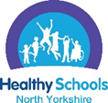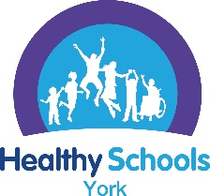
North Yorkshire and York Healthy Schools: Emotional Health & Wellbeing theme (EHWB)

Please insert your school’s name into this box
Please write in here if this application is for all schools in a federation for this theme. Please write the names of all the schools as part of this application (this does not apply to academy trusts):

PLEASE READ THIS SECTION FIRST
The process for achieving a North Yorkshire and York Healthy Schools Award
The aim of this action plan is to record progress and evidence towards achieving the EHWB theme of Healthy Schools.
- You are asked to write evidence for all criteria into the action plan but it is made clear in bold when additional information needs to be written.
- A list of the further supporting documents that need to be uploaded online as evidence is provided at the start of the action plan

Getting started in school
Lead Staff Member  Identify a named lead for the Healthy Schools Award but we do recommend a wider team work together on the award due to the different themes of the programme.  Share the EHWB action plan with the staff healthy schools team/ whole staff team and record what is already in place and is working well, using data from the Growing up in North Yorkshire survey/ School Health and Wellbeing Survey to support your responses.  Identify any outstanding elements of the EHWB criteria that need to be in place before submitting for the EHWB theme. Identify the actions required to fulfil the criteria, who is responsible and the time frame. | Pupils Healthy Schools Team  To make a submission for a healthy schools award the school must have a Pupil Healthy Schools team. This could be an existing group of pupils such as the school council, wellbeing champions, sport leaders or a newly formed group of pupils to support the school achieve the Healthy Schools award.  Share the EHWB action plan with the pupils’ healthy schools team and enable pupils to contribute to what is working well in school and what could be further improved. Data from the Growing up in North Yorkshire survey/ School Health and Wellbeing Survey could also be shared with pupils.  The aim of the pupil team is to involve them to explore what is working well, what could be better and to help implement a positive change in your school linked to this theme. | North Yorkshire: Growing up in North Yorkshire survey (GUNY)  York: School Health and Wellbeing Survey (SHWS)  If your school took part in the GUNY or York schools the SHWS we would like data from the survey to be used to support your schools submission for a Healthy Schools award.  The data could be used to show:  - what was not working well and how you have implemented actions to make improvements  - how well the provision is working in school and how this has been achieved  GUNY/ SHWS comparison data could be used from the 2024 and 2026 survey.  If your school did not take part in the GUNY / SHWS other data can be used – please identify the data source in the action plan.

Schools do not have to have any of these aspects in place to achieve a North Yorkshire & York Healthy Schools award
As we have an awareness of what needs to be in place to achieve these awards we will take this into consideration and therefore you don’t need to provide as much detail in the action plan.
Please provide information in this table if your school has engaged with any of these teams, training or awards
Organisation/ training your school may have engaged with | Information required from the school
Please tick if your school actively works with the Wellbeing in Mind Team ☐ | Please state how your school is working with the Wellbeing in Mind Team:
For North Yorkshire please tick if your school has accessed training from Compass Phoenix ☐ Emotional Health and Wellbeing training from Compass Phoenix and / or the Professional Consultation and / or make referrals into Compass Phoenix ☐ | Please state what training has been accessed from Compass Phoenix:
For York schools please tick if your school has accessed the School Wellbeing Service (SWS) ☐ School Wellbeing Service – Raise York | Please state how your school is working with the School Wellbeing Service:
Please tick if your school actively works with MyHappyMind ☐ | Please state how long the school has been working with this team and if you have achieved an award:  Bronze ☐  Silver ☐  Gold ☐
Please tick if your school has achieved a Carnegie Centre of Excellence Mental Health in Schools Award from Leeds Beckett University ☐ | Please state what level your school is at: Bronze ☐  Silver ☐  Gold ☐  and the date this was achieved:
Please tick if your school has achieved a National Nurturing Schools Award ☐ | Please provide the date when your school achieved this award:
Please add in any information about any further awards or organisations that your school actively works with to support a whole school approach to emotional health and wellbeing, inclusion and diversity:

Submitting for the EHWB theme once all elements of the action plan have been completed
Submitting for an award via the healthy school website:
Log onto https://healthyschoolsnorthyorks.org/ and sign in with your school username and password
- You are asked to write evidence for all criteria into the action plan and include photographs to support your application.
- Then complete a short online survey, essential feedback for our funders. Your action plan will then be submitted for assessment towards an award and go through the quality assurance process.

Please see the healthy schools website resources page for support, documents and information in relation to this theme and the training and events section to support staff CPD for this theme. Any questions or issues, please contact us healthyschools@northyorks.gov.uk

The following is the action plan that needs to be completed when making a submission for the EHWB theme of the Healthy Schools Award
EHWB action plan criteria- this needs to be fully completed before applying for the EHWB theme
Pupil Voice
Please write in this section what the pupil’s healthy schools team identified as the area for development in relation to the EHWB theme and what changes have been implemented to make improvements. This could be supported by a photograph for an aspect that supports the EHWB theme in school. (Please see appendix 1 at the end of this document for some examples)

Growing up in North Yorkshire Survey or for York schools the School Health and Wellbeing Survey (or other school data if the survey was not accessed by the school)
Please write in this section to showcase some data from your schools survey that relates to the EHWB theme to either show how an area was identified for development or evidence to show an improvement in provision. (Please see appendix 1 at the end of this document for some examples)

Criteria to be achieved for Emotional Health & Wellbeing theme  PLEASE provide information to show that all aspects of the criteria are in place in your school. | Please write in this column which criteria are already in place in your school.  Please include some photos in the action plan as evidence along with a short description.  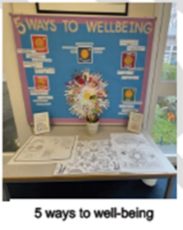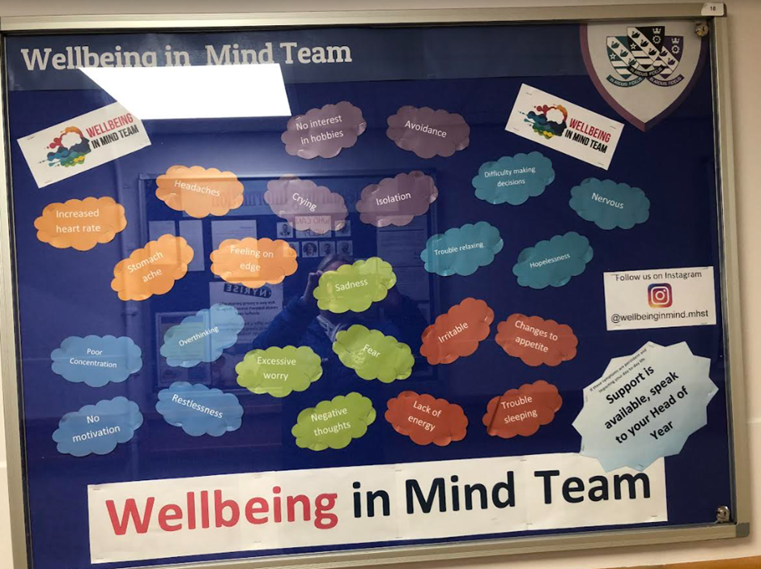 | Please write in this column actions you have worked on because of taking part in the Healthy Schools award and when they were met e.g. Oct 2025.  All actions need to be complete before applying for an award.
Senior Leadership Commitment
The school emphasises the importance of a clear vision and strategy for promoting emotional health and wellbeing for the whole school community, with senior leaders actively championing and supporting these efforts.
The schools aims, vision and values are inclusive of supporting the emotional health and wellbeing of the whole school community and promoting positive and respectful relationships across the school community.

The school website has an accessible Mental Health policy and Anti-bullying policy

EVIDENCE: please provide a link in the action plan to the school website where the following information can be accessed:
- Schools aims, vision and values
- Anti-bullying policy that is fully inclusive of the protected characteristics of the Equality Act 2010
- Whole School Mental Health Policy
Senior Lead for Mental Health

There is a named member of staff who is the emotional health and wellbeing lead in school with protected time and clear responsibilities.

The lead has accessed training to support them in their role.

Senior leaders regularly review wellbeing data and provision for pupils and report this to governors.

EVIDENCE: provide detail in the Action Plan of the named Senior Lead for Mental health, their role and responsibilities within school and actions that have been taken to improve the emotional wellbeing of the whole school community
Curriculum – Emotional Health and Wellbeing is part of the planned PSHE curriculum

There is a well-planned and taught curriculum for emotional health and wellbeing for all year groups (including EYFS and sixth form) which is meeting the requirements of the statutory Relationships, Sex Education and Health Education curriculum and the curriculum has been adapted to meet the needs of all pupils in the school.
Teaching methods are used that promote pupils’ confidence, resilience and knowledge so that they can keep themselves mentally healthy and learn how to manage their own emotions.
The taught curriculum links to and complements wider whole school activities to promote and support emotional health and wellbeing.
All aspects are regularly reviewed and evaluated to monitor the impact of the provision.
EVIDENCE: provide detail in the action plan about how the curriculum and wider whole school activities are monitored to ensure the provision is meeting the needs of the pupils (this should include photographs in the action plan)
Please provide a link to the long term PSHE curriculum plan accessible on your school website (If your school has achieved the PSHE theme of the healthy schools award the PSHE curriculum overview does not need to be uploaded again just note in the action plan that the PSHE theme has been awarded and the date it was achieved)
School Ethos and Environment
There is a positive and inclusive atmosphere where pupils feel welcome, safe, respected, valued and a sense of belonging.
There is a positive whole school culture, which fosters positive relationships and values diversity.
The school is inclusive and safe for all pupils and takes a positive approach to combating bullying, harassment and derogatory language. Pupils are reporting any incidents, and this is regularly monitored and evaluated, and data is shared with governors.
The school has a culture in which talking about emotions and feelings, mental health and well-being is the norm, where it is acceptable to ask for help, where targeted support can be provided to those with identified issues in a coherent and non-stigmatising way.
Consideration has been given to develop Young People Mental Health Champions / Wellbeing Champions. If the school does have them what are their roles and responsibilities and how is this shared with other pupils in school?

The school actively promotes self-regulation techniques to support pupils to look after their own emotional health and wellbeing and the school ethos and environment supports these approaches.

EVIDENCE: provide detail in the Action Plan of
- How the school monitors that it is an inclusive and safe place for all pupils and responds to any emerging issues
- How the school creates a ‘sense of belonging’ for all pupils
- Examples of approaches and programmes put in place to support the whole school community’s emotional and mental wellbeing
- If the school has them brief impact information on wellbeing champions
Staff CPD
Staff can access CPD to increase their knowledge of emotional health and wellbeing to equip them to be able to promote positive mental wellbeing and to identify mental health concerns.
Staff have received CPD opportunities to enable them to effectively teach a planned curriculum for emotional health and wellbeing.

All staff have received training to ensure they are confident to challenge discriminatory, harassment, prejudicial, derogatory or aggressive language related to the protected characteristics under the Equality Act 2010 and this language is consistently challenged.
EVIDENCE: provide detail in the Action Plan of staff training and the impact it has had on provision.
Working in partnership with Parents / Carers
The school actively engages with parents and carers in promoting pupils' well-being and providing them with resources and support.
Parents and carers are regularly informed about the proactive approach the school takes to support pupils’ wellbeing.
There could be a section on the school website providing information and support around emotional wellbeing.
EVIDENCE: provide detail in the Action Plan:
- how the school actively engages with parents and families around emotional wellbeing
- and if applicable a link to the emotional wellbeing section on the school website
Targeted Support and Provision
The school is effectively using tools to assess, understand and plan a response to pupils’ emotional health and wellbeing needs and measures the impact of interventions to improve wellbeing.
The school ensures that all pupils are aware of what pastoral care is available in school and all pupils have a trusted adult they can talk to and this is regularly reviewed.
The school is effective at identifying and ensuring timely targeted support for pastoral support in school and ensuring appropriate referral to support services for pupils with identified mental health needs.
Staff have an understanding and awareness of the pupils who are at greater risk of experiencing poorer mental health e.g those in care, young carers, LGBT, SEND, armed forces families etc.

EVIDENCE: provide detail in the Action plan of in-school support for identified pupils and examples of partner organisations worked with/ referred onto.
NEXT STEPS. What are your next identified steps to continue to ensure the effective implementation of a whole school approach to Emotional Health & Wellbeing?

Detail below.

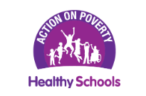

As a school alongside continuing to achieve Healthy Schools Awards you may want to consider achieving the Action on Poverty Certificate of Recognition to support schools consider every part of school life that may place barriers in the way of children’s participation and learning, pose income-related exclusion and stigma or put pressure on low-income families.

The Action on Poverty guidance includes assessment tools and examples of practical actions that schools can take to mitigate the impact of poverty within their school environment and improve the school experience for all pupils.

The guidance and self-assessment tools along with more information can be accessed here along with a short video introducing the guidance.

The submission for the Action on Poverty certificate follows the healthy school submission dates. For any further information or guidance please contact healthyschools@northyorks.gov.uk

Appendix 1: Pupil Healthy Schools Team

Primary school combining using data from their Growing up in North Yorkshire Survey (GUNY) 2024 and pupils leading on some of the learning
The GUNY survey showed:
- Sometimes it’s hard to say ‘no’ to friends
- Some boys had worries about being bullied
- Some girls had worries about being picked on because of how they looked
(even though at the time of the survey, there were no accounts of experiencing bullying, racism or online abusive messages)
The school did:
- ‘Upstander’ training delivered by Diversity Role Models for School Council and Wellbeing Champions, so that they can model this behaviour – we pledged to be Upstanders
- Poster campaign about being an ‘Upstander’ by children for children
- Equalities and diversity display made alongside children
- Bought books for school that explore difference and made staff aware of them
- Wellbeing Champions taught about positive body image, using Compass Phoenix materials
- Wellbeing Champions came up with some ideas to share this learning about being an Upstander with their Key Stage 2 peers
Appendix 2: How schools have effectively used and responded to the Growing up in North Yorkshire Data

Secondary school using their Growing up in North Yorkshire data
- Identified that 25% of pupils receive negative comments outside of lesson – as a response to this the school have added additional staff to duties and key areas.
- 55% said they did not report sexual harassment to adults – in response to this the school have introduced a QR online form for students to scan around the school and report without others knowing through their IPAD.
- 64% of pupils said they worried about issues – the school has a section on smooth wall pulse which directs students to resources available on line, in person and to external agencies which have been promoted through PSHE lessons, form time and assemblies

Primary school using their Growing up in North Yorkshire data:
- 33% of Year 6 pupils worried about transitioning to secondary school.
- The school wellbeing lead now attends the secondary school transition day with the Year 6 pupils
- The Year 6 teacher has sessions with the Year 6 pupils on packing their school bag for secondary school, reading a timetable and moving to different lessons and practiced putting on a tie.
- 6% of Year 6 pupils now feel worried about the transition to secondary school.

