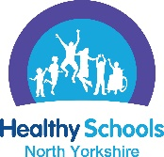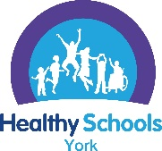
North Yorkshire and York Healthy Schools - Personal Social Health Education (PSHE) theme

Please insert your school name into this box
Please write in here if this application is for all schools in a federation for this theme. Please write the names of all the schools as part of this application (this does not apply to academy trusts):

PLEASE READ THIS SECTION FIRST
The process for achieving a North Yorkshire and York Healthy Schools Award
The aim of this action plan is to record progress and evidence towards achieving the PSHE theme of Healthy Schools.
- You are asked to write evidence for all criteria into the action plan and include photographs to support your application.
- A list of the further supporting documents that need to be uploaded online as evidence is provided at the start of the action plan

Getting started in school
Lead Staff Member  Identify a named lead for the Healthy Schools Award but we do recommend a wider team work together on the award due to the different themes of the programme.  Share the PSHE action plan with the staff healthy schools team/ whole staff team and record what is already in place and is working well, using data from the Growing up in North Yorkshire survey / School Health and Wellbeing Survey to support your responses.  Identify any outstanding elements of the PSHE criteria that need to be in place before submitting for the PSHE theme. Identify the actions required to fulfil the criteria, who is responsible and the time frame. | Pupils Healthy Schools Team  To make a submission for a healthy schools award the school must have a Pupil Healthy Schools team. This could be an existing group of pupils such as the school council, wellbeing champions, sport leaders or a newly formed group of pupils to support the school achieve the Healthy Schools award.  Share the PSHE action plan with the pupils’ healthy schools team and enable pupils to contribute to what is working well in school and what could be further improved. Data from the Growing up in North Yorkshire survey / School Health and Wellbeing Survey could also be shared with pupils.  The aim of the pupil team is to involve them to explore what is working well, what could be better and to help implement a positive change in your school linked to this theme.  (See appendix 1 at the end of the action plan for a suggestion on how you can feedback on pupil involvement) | North Yorkshire: Growing up in North Yorkshire survey (GUNY)  York: School Health and Wellbeing Survey (SHWS)  If your school took part in the GUNY / SHWS we would like data from the survey to be used to support your schools submission for a Healthy Schools award.  The data could be used to show:  - what was not working well and how you have implemented actions to make improvements  - how well the provision is working in school and how this has been achieved  GUNY Comparison data could be used from the 2022 and 2024 survey.  If your school did not take part in the GUNY/ SHWS other data can be used – please identify the data source in the action plan.

Submitting for the PSHE theme once all elements of the action plan have been completed
Submitting for an award via the healthy school website:
Log onto https://healthyschoolsnorthyorks.org/ and sign in with your school username and password
- Once all criteria have been achieved, please work through the PSHE ‘Theme content’ section online, uploading evidence where required.
- Finally upload your completed action plan and supporting photographs. Please can all photographs be copied into a word document along with a short summary of what the photograph is showing.
- Then complete a short online survey, essential feedback for our funders. Your evidence will then be submitted for assessment towards an award and go through the quality assurance process.

Please see the healthy schools website resources page for support, documents and information in relation to this theme and the training and events section to support staff CPD for this theme. Any issues, please contact us healthyschools@northyorks.gov.uk

The following is the action plan that needs to be completed when making a submission for the PSHE theme of the Healthy Schools Award

PSHE action plan criteria- this needs to be fully completed before applying for the PSHE theme
Pupil Voice
Please write in this section what the pupil’s healthy schools team identified as the area for development in relation to the PSHE theme and what changes have been implemented to make improvements. This could be supported by a photograph of a PSHE noticeboard or an aspect that supports the PSHE theme in school.

Growing up in North Yorkshire Survey or for York schools the School Health and Wellbeing Survey (or other school data if the survey was not accessed by the school)
Please write in this section to showcase some data from your schools survey that relates to the PSHE theme to either show how an area was identified for development or evidence to show an improvement in provision.

Criteria to be achieved for the PSHE theme of the Healthy Schools Award  PLEASE provide information to show that all aspects of the criteria are in place in your school. | Please write in this column which criteria are already in place in your school.  Please include some photos in the action plan as evidence along with a short description.  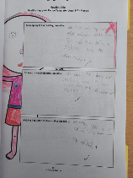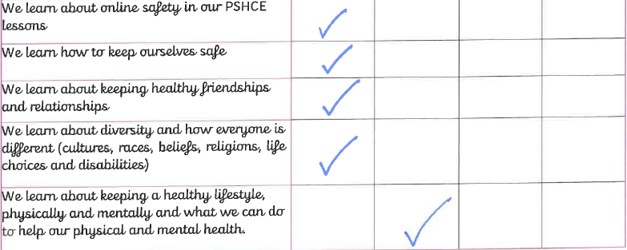 | Please write in this column actions you have worked on because of taking part in the Healthy Schools award and when they were met e.g. Oct 2025.  All actions need to be complete before applying for an award.
Overview of the planned PSHE curriculum is on the school website

A well taught and planned PSHE curriculum is in place for all pupils, inclusive of EYFS and sixth form if applicable.
EVIDENCE: please provide a link in the action plan to the school website where the following information can be accessed:
- Intent, implementation and impact for the PSHE curriculum
- Overview of the planned PSHE curriculum for all year groups that reflects the updated DfE RSHE guidance 2025
- Statutory Relationships and Sex Education policy that is inclusive of the updated DfE RSHE guidance 2025
Curriculum: including assessment of pupil’s progress

There is a taught planned programme for all year groups (including EYFS and sixth form where applicable) and all pupils are engaging in the curriculum.

Effective resources are in place to deliver the PSHE curriculum which is inclusive of the requirements of the statutory relationships, relationships and sex education and health education curriculum; and focuses on the needs of the pupils in that school community including contextual safeguarding concerns.

The planned PSHE curriculum is fully inclusive of the protected characteristics in the Equality Act 2010 and British Values supported by an inclusive whole school culture.

The planned PSHE curriculum has adequate curriculum time.

All pupils are making progress in achieving the expected educational outcomes for PSHE.

EVIDENCE: detail in the action plan:
- Which resources are used to deliver the PSHE curriculum
- How does the school record pupils progress in the PSHE curriculum and if applicable provide some photos within the action plan to show some pupils PSHE work.
- How does the school adapt the curriculum to meet the needs of SEND and Vulnerable learners

Subject Leadership

There is a named PSHE subject lead in school with protected time and clear responsibilities.

All aspects of the PSHE curriculum are regularly reviewed and evaluated to monitor the impact of the provision and to ensure all pupils are making progress in achieving the expected educational outcomes for PSHE (this could include lesson walk throughs, PSHE book looks, pupil voice).

The monitoring of the PSHE curriculum is part of the curriculum monitoring cycle with SLT and governors.

EVIDENCE: detail in the action plan:

- How the PSHE subject lead effectively leads the subject across the school and effectively monitors the planned PSHE curriculum
- How the school ensure all pupils are engaging in the PSHE curriculum with a focus on SEND learners and vulnerable pupils
- How SLT and governors are being informed about the quality of the PSHE provision.
Staff CPD
The PSHE subject lead has access to regular CPD to support the effective delivery of PSHE and they have opportunities to disseminate the learning to other members of staff. This could include attending the termly free North Yorkshire and York PSHE network meetings

All staff have received training on establishing and maintaining a safe teaching and learning environment in the classroom when delivering PSHE lessons.

All staff feel confident teaching PSHE with access to on-going CPD based on their identified needs.

Expert visitors are used to enhance the learning through the PSHE curriculum, rather than a replacement for teaching by staff.
EVIDENCE: detail in the action plan the staff CPD and what impact this has had on provision.
If applicable the school is accessing products from the Governments Period Poverty Scheme including the organic and re-usable products. These products are freely accessible for pupils to access and consideration has been given for over the school holidays for families in need.

Re-usable period products are included and shown as part of the puberty curriculum.

EVIDENCE: detail in the action plan how period products are accessible for all pupils and how this is communicated to pupils.

Working in partnership with parents/ carers
The school actively works in partnership with parents/ carers to inform them about the planned PSHE curriculum including the statutory relationships, sex and health education curriculum
Families are aware of the schools focus on PSHE and can access information to support their own and their child’s learning and understanding for the different topic areas.
EVIDENCE: detail in the action plan how families are informed about the PSHE curriculum and any links on the school website to supporting information for families.
Extra Curriculum Provision and Support

The taught PSHE curriculum links to and compliments the wider whole school activities to promote and support personal development and wellbeing and the enrichment opportunities such as leadership roles and being responsible citizens.

Pupils are signposted to appropriate support both within school and supporting external agencies. For example this could include information about how to access support for health issues, sexual health, substance misuse and mental health concerns.

EVIDENCE: detail in the Action Plan how PSHE links to wider aspects of personal development and wellbeing and enrichment opportunities and the range of services that pupils are signposted to.

NEXT STEPS
What are your next identified steps to continue to ensure the effective implementation of a whole school approach to PSHE?

Detail below.

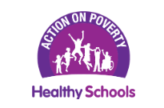

As a school alongside continuing to achieve Healthy Schools Awards you may want to consider achieving the Action on Poverty Certificate of Recognition to support schools consider every part of school life that may place barriers in the way of children’s participation and learning, pose income-related exclusion and stigma or put pressure on low-income families.

The Action on Poverty guidance includes assessment tools and examples of practical actions that schools can take to mitigate the impact of poverty within their school environment and improve the school experience for all pupils.

The guidance and self-assessment tools along with more information can be accessed here along with a short video introducing the guidance.

The submission for the Action on Poverty certificate follows the healthy school submission dates. For any further information or guidance please contact healthyschools@northyorks.gov.uk

Appendix 1: Pupil Healthy Schools Team - A suggested approach is the You said… We did… Feedback on the changes …

For example:
You said: Not all pupils could talk confidently about their learning in PSHE and the percentage of pupils finding a range of PSHE lessons as useful from the GUNY survey were quite low:
- 39% found lessons on emotional health and wellbeing as useful
- 21% found lessons on growing up and body change as useful
- 36% found lessons on alcohol as useful

We did: The PSHE lead accessed PSHE subject leadership training and all staff received training on effective delivery of the statutory relationships, sex and health education curriculum. A whole school planned PSHE curriculum has been implemented, including asking and responding to what pupils felt was important to them to include in the curriculum and the PSHE subject lead is effectively monitoring the taught planned curriculum, including pupil feedback sessions.

Feedback on the changes / positives: Pupils can now talk confidently about their learning in PSHE which is taught in every class and from the recent GUNY survey:
- 90% of pupils now find lessons about emotional health and wellbeing as useful’
- 63% of pupils now find school lessons about growing up and body changes as useful
- 60% found lessons on alcohol as useful

